constructed oyster reefs as sediment stabilisers and ecological engineers: A dutch case study

Anneke van den Brinkª (now NSW Department of Planning and Environment) anneke.vandenbrink@environment.nsw.gov.au
João N. Salvador de Paivaª; Silvia Cilli^{b}, Matthijs Boersemaª, Paolo Ciavola^{b}, Brenda Walles^{cd}, Tom Ysebaert^{cd}, Tjeerd J. Bouma^{ace}

CONDITIONAL OUTCOMES OF ECOSYSTEM ENGINEERING
Global degradation and the collapse of valuable coastal ecosystems has resulted in major efforts to reestablish ecosystem engineering species that provide valuable services like ecosystem-based coastal defense (EBCD). However, conditional outcomes of ecosystem engineering effects make it hard to predict the services provided by such restored systems.

In this study we focused on reefs constructed with Crassostrea gigas shells on a sand nourishment at the Oesterdam, in the Oosterschelde tidal bay in the Netherlands. We investigated how the environmental setting, waves and currents, influence sediment stabilisation, as well as oyster spat recruitment and the development of associated biodiversity.

OYSTER REEFS
Although there was no clear difference in oyster spat recruitment per reef, results showed an increase in oyster spat recruitment from 86.7 ± 13.4 ind.m² in 2014 to 185.8 ± 20.25 ind.m² in 2017. Regarding vertical growth, reef D (current dominated) increased 1.0 cm/year -1 while wave dominated reefs increased 1.7cm/year -1 (reef C) and reef D 3.3cm/year -1 (reef D).

The oyster reefs provided habitat for a range of species that would otherwise not be present on the sand flats, including non-indigenous species. The differences between reefs in terms of species composition was negligible as the reefs all provided comparable habitats for the same type of species. However, Reef C was more loosely packed compared with the other reefs and this may have resulted in the greater dominance of periwinkles, the noticeably lower algae coverage, and dominance of the algae cover being Fucus vesiculosus rather than Polysiphonia lanosa.

SEDIMENT
Sediment accretion adjacent to the reefs occurred for all reefs but displayed different patterns and rates. The reef exposed only to currents stabilised the adjacent sediment over its full length and showed an overall trend of accretion. The reefs exposed to both waves and currents accumulated sediment in a salient and tombolo shape but showed an overall trend of erosion.

The oyster reefs stabilised sediment up to several tens of metres from the reef, with the scale of effect depending both on local hydrodynamic conditions as well as the reef structure and dimensions. The reef exposed only to currents stabilised the adjacent sediment over its full length, whereas the reefs exposed to both waves and currents accumulated sediment in a salient and tombolo shape, but a general trend of erosion was observed. In both cases, the sediment stabilisation effect extended beyond the height of the reefs.

Overall, our results provide valuable insight in the conditional outcome of ecosystem engineering in response to physical forcing, which is crucial knowledge for designing ecosystem-based solutions and ultimately to improve current understanding for ecosystem management.

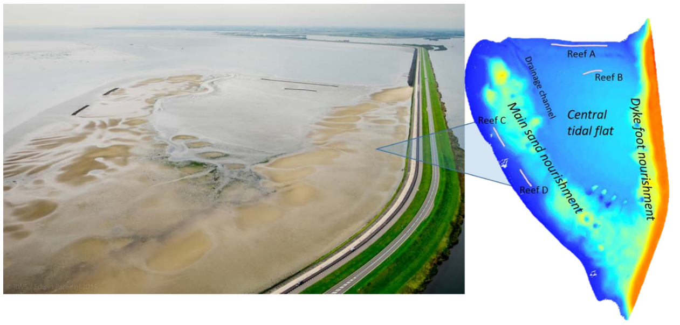
REFERENCES
Bouma, van Belzen, Balke, Zhu, Airoldi, Blight, Davies, Galvan, Hawkins, Hoggart, Lara, Losada, Maza, Ondiviela, Skov, Strain, Thompson, Yang, Zanuttigh, Zhang, Herman, (2014). Identifying knowledge gaps hampering application of intertidal habitats in coastal protection: Opportunities &amp; steps to take. Coast. Eng. 87, 147–157.

Salvador de Paiva, Walles, Ysebaert, Bouma, (2018). Understanding the conditionality of ecosystem services: The effect of tidal flat morphology and oyster reef characteristics on sediment stabilization by oyster reefs. Ecol. Eng. 112, 89–95.

Walles, Mann, Ysebaert, Troost, Herman, Smaal, (2015). Demography of the ecosystem engineer Crassostrea gigas, related to vertical reef accretion and reef persistence. Estuar. Coast. Shelf Sci. 154, 224–233.

Walles, Troost, van den Ende, Nieuwhof, Smaal, Ysebaert, (2016). From artificial structures to self-sustaining oyster reefs. J. Sea Res. 108, 1–9.

ª Building with Nature group, HZ University of Applied Sciences, Vlissingen, The Netherlands
^{b} University of Ferrara, Dept. Physics and Earth Sciences, Italy
^{c} Royal Netherlands Institute for Sea Research (NIOZ), Yerseke, The Netherlands
^{d} Wageningen Marine Research, Yerseke, The Netherlands
^{e} Faculty of Geosciences, Utrecht University, The Netherlands

