FIRST PROJECT OF BIODIVERSITY RESTORATION OF COASTAL AREAS IN POLAND

Grzegorz Różyński, Inst. Hydro-Engineering, Gdańsk, Poland, grzegorz@ibwpan.gda.pl
Piotr Szmytkiewicz, Inst. Hydro-Engineering, Gdańsk, Poland, P.Szmytkiewicz@ibwpan.gda.pl

INTRODUCTION
Increasingly difficult relations with Russia have triggered the construction of an independent passage from the Baltic Sea to the Polish part of Vistula Lagoon, cf. Fig. 1 (top), operational since Sept. 2022. The Polish part of the lagoon is a NATURA2000 site, so environmental disturbances requires compensation measures, one of which is the 1st coastal biodiversity restoration project. It is based on the building with nature paradigm.
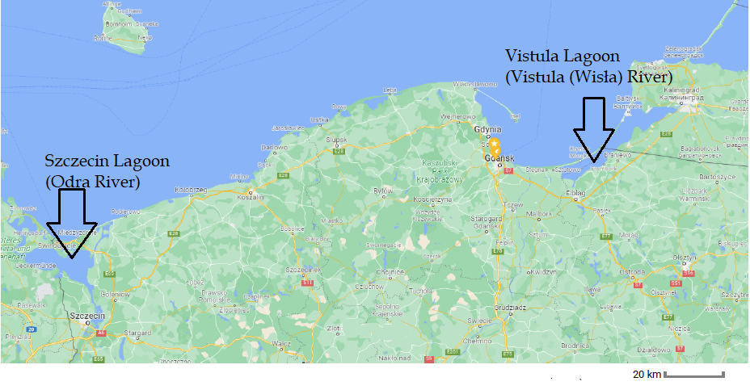
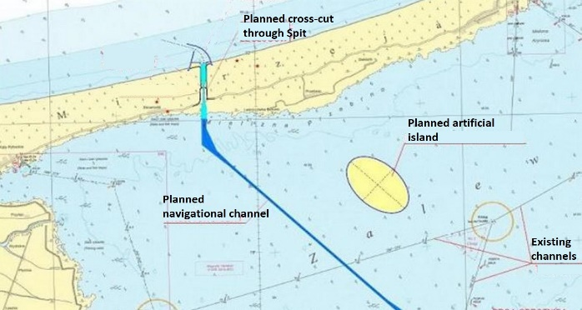
Figure 1 Transboundary lagoons on Polish Baltic Sea coast (top), new navigation route in Vistula Lagoon (bottom)

BIODIVERSITY RESTORATION FUNCTIONS
The new infrastructure involves extensive earth works to cut the Spit and execute the dredging operations during and after completion of the project. Fig. 1 (bottom) demonstrates the location of an artificial island in Vistula Lagoon, intended to store the sediment and simultaneously serve as biodiversity restoration site. This location was selected basing on simulations of wave and current field patterns, aimed at minimization of their changes after the island is built. The island comprises 136 ha to be filled during the construction phase and the remaining 45 ha to serve as operational sediment storage facility, cf. Fig. 2. The main innovation is managed vegetation of the larger part by periodic mowing of planted grasses, done annually every summer, to foster its colonization by birds targeted for restoration by optimizing their preferred habitat. Hence, shrubs will be eliminated to repel cormorants – once an endangered species, but nowadays overabundant in the area. The primary restoration function is the provision of the resting grounds for ducks (gadwall, shoveler, widgeon), grey, bean and white-fronted geese, and later the hatching grounds for snipe, northern lapwing and redshank. The island is intended to compensate the habitat loss resulting from construction of the new navigation channel. Moreover, these ecosystem services. will be additionally protected by restricted access to the site, being under full jurisdiction of coastal authorities. Biodiversity restoration will be widely consulted with ornithologists, who will be assisting in the implementation process and monitoring the progress. Additional benefit will consist in natural transformation of shallow and muddy lagoon bed around the island’s banks into a spawning area of important, local fishes (bream, pike perch) by inducing natural appearance of reeds, as is anticipated by ecologists. The development of this spawning ground will be consulted with ichthyologists, who will be monitoring the progress as well. In this way multi-faceted nature based solution will be attained.
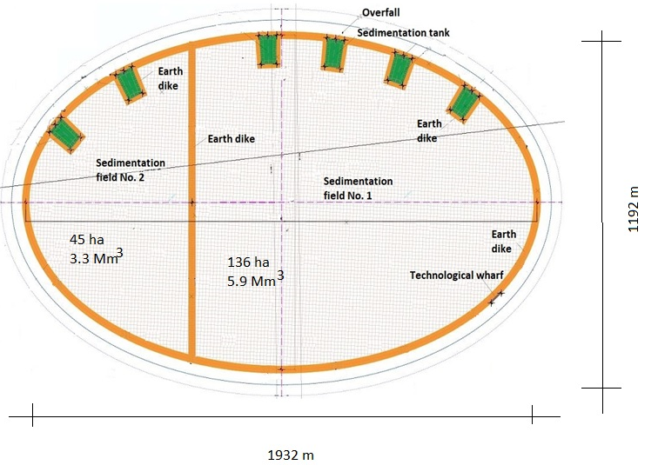
Figure 2 Artificial island: biodiversity restoration site located at larger compartment
Fig. 3 presents the ellipsoidal rim perimeter under construction. Due to very soft bed sheet piles had to be driven 9 m into the muddy bottom to secure their stability. Moreover, the inner and outer row are braced near their top with multiple beams; the island will extend ca. 2 m above msl.
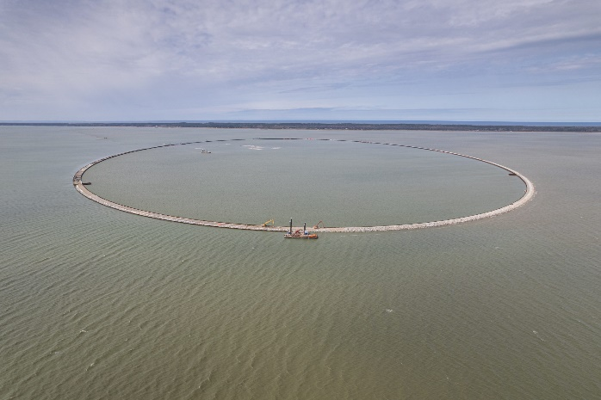
Figure 3 Artificial island: the rim perimeter.
The outer part of the rim top was covered with stones to prevent the effects of ice action in winter seasons, cf. Fig. 4. The impact of ice had to be taken into account, because the thickness of ice can exceed 20 cm in severe winters and the rim should withstand the forces it can generate.
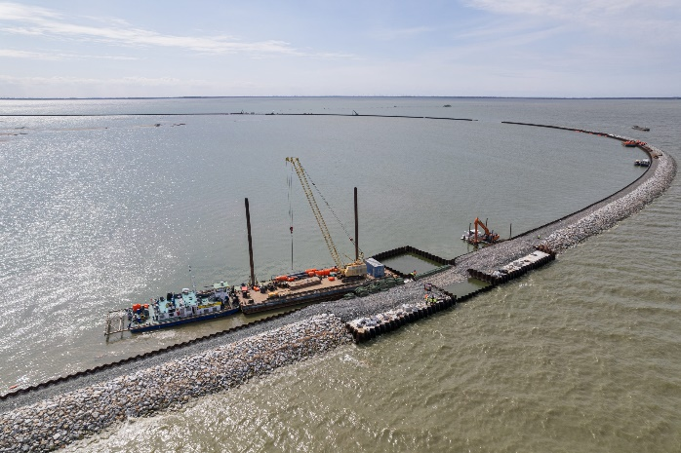
Figure 4 Artificial island: rim top armor against ice impacts.

CARBON STORAGE IMPLICATIONS
Apart from examination of restoration performance in the coming years, carbon storage potential of the site will be investigated using the TESSA toolkit. The results will be compared with Chełminek island in Szczecin lagoon, see left part of Fig. 1, top. That island was built artificially in early 20th Century. It encompasses ca. 8 ha and was gradually vegetated naturally after 1889 and in particular after termination of sediment deposition in 1970s, see Fig. 5 and the bottom right corner of Fig.6. The main aim of this comparison is identification of potential carbon storage benefits of managed vs. natural vegetation. Natural emergence of woods at Chełminek favored abounding cormorants, whose excrements are detrimental for vegetation and local fish stocks in the long run. Therefore, Fig. 5 illustrates one of additional targets of managed vegetation, namely, control of the population of cormorants by elimination of shrubs and trees. Interestingly, successful spontaneous development of reeds was reported in the nearshore region of Chełminek, cf. Kowalski et al., 2013, which indicates similar derivative ecosystem services can be expected at the study site at Vistula Lagoon.
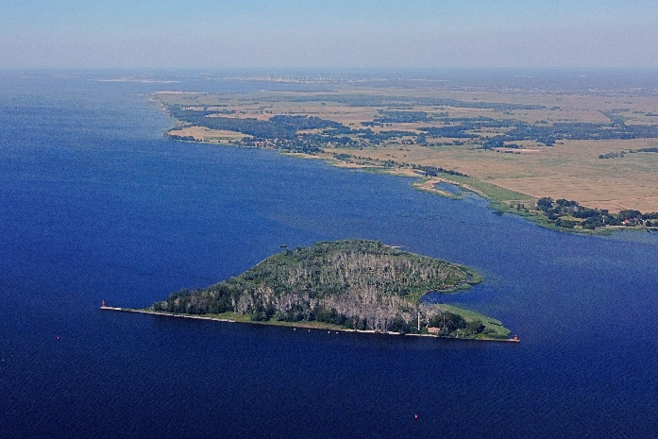
Figure 5 Szczecin Lagoon – naturally vegetated artificial Chełminek island

OUT- AND UPSCALING POTENTIAL
Rapid expansion of navigation infrastructures in Poland produces opportunities for out- and upscaling of this pilot project. Currently, three artificial islands are executed in the Szczecin lagoon. Two most advanced, referred to as W22 and W28, see Fig. 6, emerge as deposition sites for sediment dredged during extension for the main navigation channel in that lagoon (Kanał Piastowski in Fig. 6). Those islands have circular shapes with the diameters of 1250 m for W22 and 1780 m for W28; the no-go zones are larger and measure 1950 m and 2470 m respectively. Both islands are designed to comprise 40 million m³ of sediment, and are much bigger than the pilot island in Vistula Lagoon. Hence, experience gained during implementation of this pilot can be treated as a more general learning process towards achieving excellence in biodiversity restoration in basins, mostly lagoons and estuaries, located in moderate latitudes.
Figure 6 Szczecin Lagoon – locations of new artificial islands: W22 and W28

ACKNOWLEDGEMENTS
This work received funding from the European Union’s Horizon 2020 research and innovation programme, within the Large Scale RESToration of COASTal Ecosystems through Rivers to Sea Connectivity (REST-COAST) project, under Grant Agreement 101037097.

REFERENCES
Kowalski, Banaś-Stankiewicz, Wróbel, Malinowski, Niedźwiecki (2013): Characteristics of selected components of the natural environment of the Chełminek island. Part 2. Current status and the natural value of vegetation cover of the Chełminek island., Folia Pomer. Univ. Technol. Stetin. 2013, Agric. Aliment. Pisc., Zootech. 307 (28), pp. 47-60 (in Polish).

