UNRAVELLING THE DRIVERS OF SHORELINE CHANGE

Arjen Luijendijk, Deltares & Delft University of Technology, arjen.luijendijk@deltares.nl
Etienne Kras, Deltares
Floris Calkoen, Delft University of Technology & Deltares
Antonio Moreno-Rodenas, Deltares

INTRODUCTION
The availability of public satellite imagery, combined with advanced image processing, machine learning and cloud computing, triggered an unprecedented flow of information relevant to the coastal engineering community. From satellite imagery we can nowadays for example derive subtidal bathymetry, beach slopes, beach sediment types and coastline dynamics, at accuracies that increasingly allow for engineering applications. Regarding the latter two, global datasets on the occurrence of sandy beaches and historic shorelines have recently become available (Luijendijk et al., 2018). The high spatial and temporal resolution of this information yields more comprehensive understanding of our coasts and its dynamics (see Figure 1). This is not only of great added value in data-poor environments, it will also allow for more cost-effective coastal monitoring in data rich environments as the necessity of in-situ measurements will reduce in future. In this study we will expose the main drivers for coastal change for sandy and muddy coasts using satellite-derived shoreline (SDS) and machine learning algorithms.
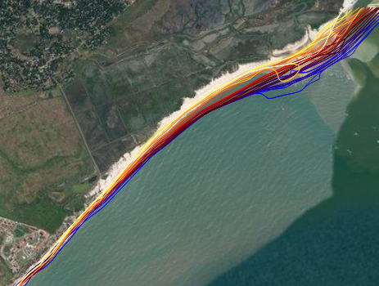Figure 1 – Satellite-derived shorelines downdrift of an inlet system. (Mozambique). Dark blue represents 1984, while yellow represents 2016.

METHODS
Satellite imagery already proved to be a promising data source to derive historic shoreline behavior on a global scale. To enable the use of such a large amount of satellite data, image processing techniques are introduced to interpret such large datasets. Furthermore,
Machine Learning (ML) algorithms allow for an extra in-depth understanding of the shoreline dynamics, while growing computational power and standardization of ML packages, opens possibilities for studying shoreline dynamics on a global scale.

For this purpose, a feature extraction and quantification algorithm is developed and tested on local scales prior to running it globally. Hereafter, various human and natural drivers are manually related to features on specific local sites, as it was already proved that the spatiotemporal variability within features is largely in line with drivers listed in literature. Subsequently, an unsupervised clustering method is employed to automatically group similarities in spatiotemporal variable characteristics in shoreline dynamics on a global scale (Kras, 2020).

After collecting monthly time series of shoreline positions for these dynamic areas, time series decomposition is applied to unravel distinct driver-specific temporal and spatial signatures.

RESULTS AND IMPACT
A method has been developed to automatically detect drivers of coastal changes using high-resolution temporal and spatial shoreline positions. In this way, human drivers, such as nourishments, ports, coastal structures, and natural drivers, such as RSLR, inlet systems, and storms, have been identified for multiple sites across the globe. Information on the governing drivers for local coastal change is one of the key elements required for future shoreline projections.

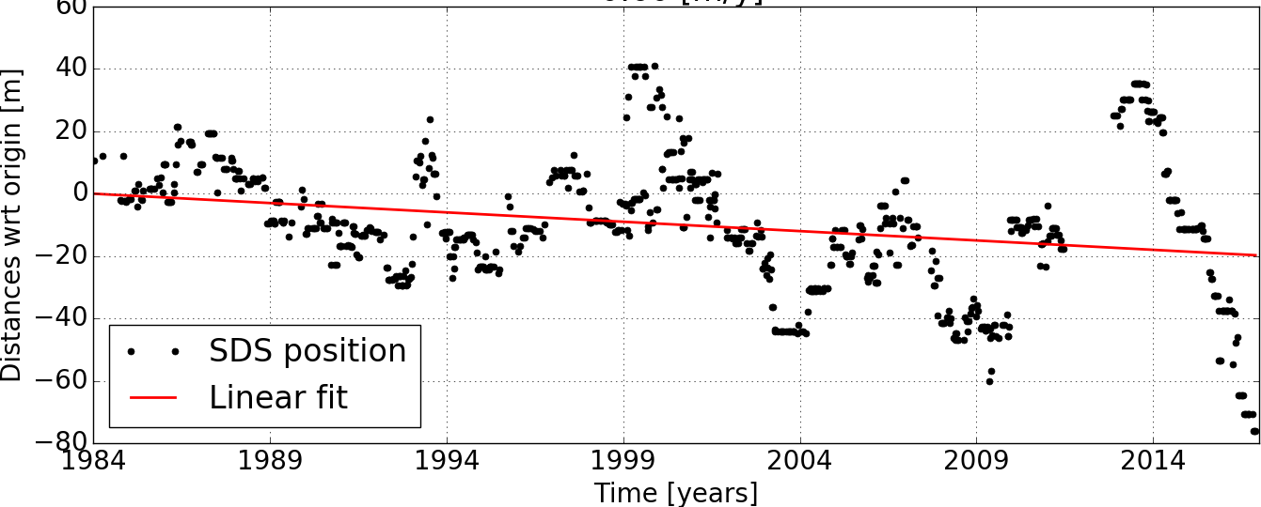

Figure 2 – Monthly time series example showing satellite-derived shoreline positions for a sandy beach.

REFERENCES
Luijendijk, A.P., Hagenaars, G., Ranasinghe, R., Baart, F., Donchyts, G., and Aarninkhof, S.G.J. The State of the World’s Beaches, Nature Scientific Reports 8 (2018).
Kras, E. (2019). MSc thesis: Planetary-scale classification of natural and human-induced sandy shoreline evolution.

