UNDERSTANDING THE COASTAL RROCESSES WITHIN GUICHEN BAY AND CAPE DOMBEY THROUGH AIRBORNE LIDAR BATHYMETRY

Mick Hawkins, Fugro Australia Marine, m.hawkins@fugro.com
Paul Seaton, Fugro Australia Marine, p.seaton@fugro.com
Patrick Hesp, Flinders University, Patrick.hesp@flinders.edu.au
Graziela Miot da Silva, Flinders University, Graziela.miotdasilva@flinders.edu.au

The South East Coastline of South Australia is a dynamic environment, with numerous beaches, shallow reef areas and exposed limestone cliffs. As such, it is a highly susceptible area to the impacts of climate change and coastal erosion.

The Robe Council and Flinders University are conducting research on the seabed surrounding Cape Dombey and Guichen Bay to better understand and ultimately determine appropriate coastal management plans for the area. Bathymetry within the region is out of date and unreliable for accurate modelling for their research and Fugro will work with both parties to deliver high resolution topographic and bathymetric data over the town, coastline and the associated waters.

FLINDERS UNIVERSITY RESEARCH
The LiDAR will be utilised in providing bathymetric and marine habitat data to support a new coastal processes study being conducted by Flinders University academics and students in conjunction with Robe District Council. The high resolution bathymetric data will be utilised
- to provide a better understanding of sediment transport pathways in the nearshore,
- in Delft3D modelling of waves and nearshore-surfzone sediment transport,
- in mapping of marine habitats,
- connecting historical beach and surfzone topographic surveys with high resolution LiDAR 3D digital surface models, and,
- baseline data to be used in XBeach modelling and future sea level rise modelling.
The data will also be used to examine possible sites for new artificial reefs construction and will provide a superb baseline for the on-going beach-surfzone-nearshore monitoring being set up along the Robe township beaches and in Guichen Bay.

FUGRO AUSTRALIA MARINE
Fugro will utilize the Australian made Airborne Lidar Technology, LADS HD+, a high powered bathymetric lidar sensor, combined with a topographic and bathymetric Riegl VQ-820-G and Phase One digital camera installed into a light aircraft and operated from Adelaide Airport.

Following data acquisition and processing, data delivered to Flinders University will include classified point cloud data, high resolution Digital Elevation Models (DEM) and other bespoke products specific for their research.

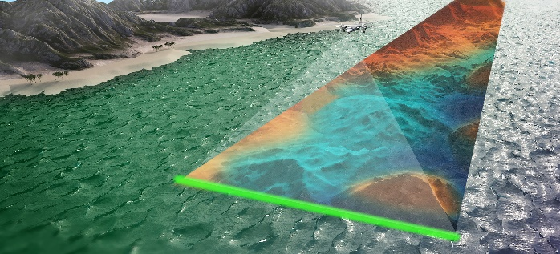
Figure 1 – Fugro Lidar Acquisition

GAIA Digital Ecosystem
The Future is…. Digital. BIM and Digital Twins are not just for engineering, they are the here and now, and can provide smart, visual data management approaches for understanding natural environmental site characterisation. The Gaia digital ecosystem developed by Fugro from the Australian developed Roames technology incorporates marine and coastal environment data sets from multiple sources. The cloud based system applies machine learning and artificial intelligence for data processing and modeling, and generates 2D, 3D and 4D visualizations of the data. Gaia provides a digital twin living lab in which risk simulation models can predict impacts on communities, infrastructure and natural capital. This delivers critical insights about the impacts of changes to the coastline and can play a role in protecting the environment and managing the impacts of climate change.

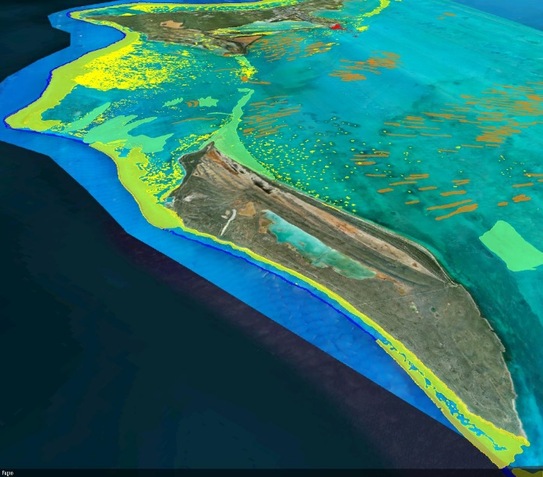
Figure 2 – GAIA Digital Twin image of auto-classified seabed

Using Gaia Digital Ecosystem, Fugro will support the Robe Council and Flinders University not only with data acquisition, but analytics and better, easier and more advanced decision making capabilities. One of the biggest barriers to decision making and utilising spatial twining is access and sharing data. Many decision makers struggle with determining appropriate methods for managing coastlines due to a lack of:
- substantial data amount
- sufficient data quality
- integrating multiple datasets

Gaia Digital Ecosystem is the world’s first multidimensional digital geo twin. From early planning to living engineering and asset management, we can connect communities and decision makers by providing critical coastal climate risk insights. Data integration, analytics and visual scenario planning and decision making are now available within one virtual and multiuser friendly environment. This approach allows Gaia to become a single source of truth for coastal insights that can support early risk planning, nature-based design and coastal engineering, asset management and early warning systems.

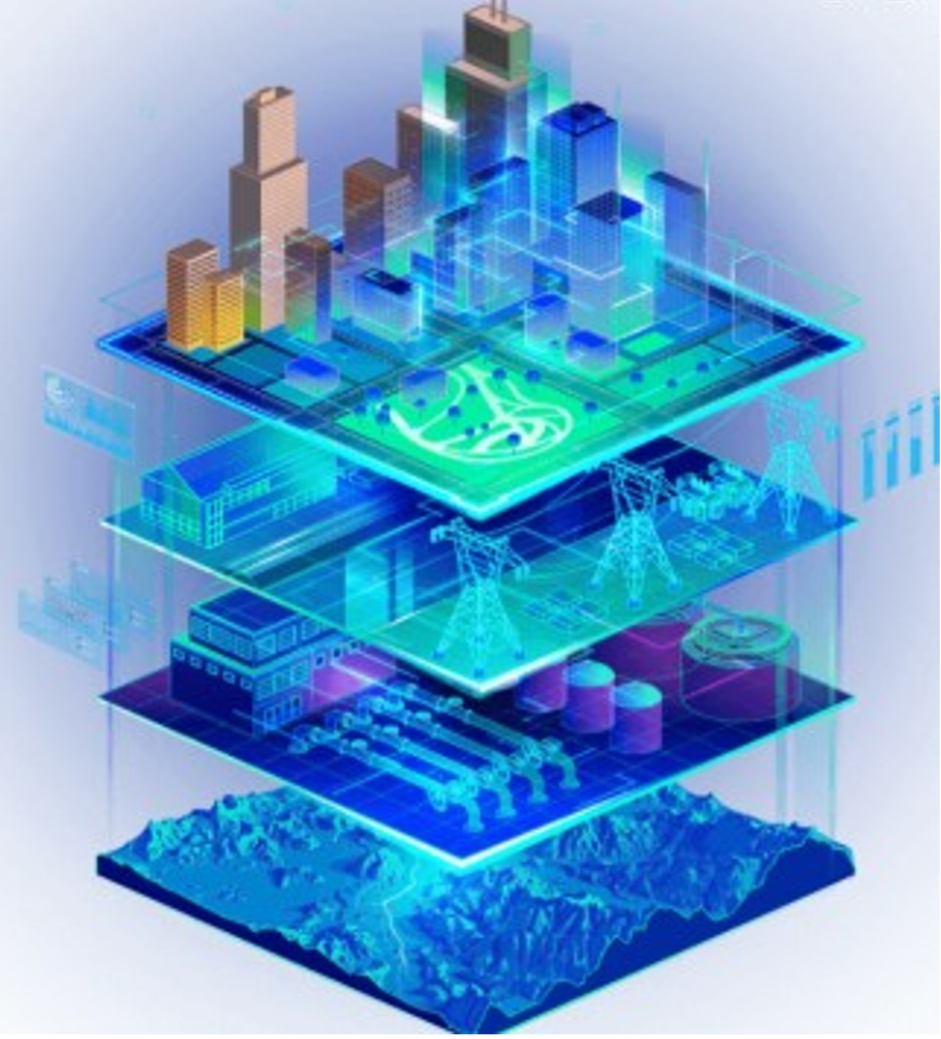
Figure 3 – GAIA Digital Twin draws on 4 geo dimensions of capabilities to build a needs-based solution tailored localised needs

This presentation will focus on the data acquired, how it has been used by Flinders University research group and the Robe Council, and the benefit of visualisation within the GAIA digital twin environment.

