2DV RANS-VOF NUMERICAL MODELING OF
A MULTI-FUNCTIONAL HARBOUR STRUCTURE
Sara Mizar Formentin, Giuseppina Palma¹, Pasquale Contestabile,
Diego Vicinanza^{2,}, Barbara Zanuttigh¹
This paper is focused on the analysis of a multifunctional structure developed by the Second University of Naples, named OBREC, which is an Overtopping Breakwater for Energy Conversion. The hydraulic and structural performance are evaluated by means of the 2DV numerical model IH-2VOF developed by the University of Cantabria, in terms of average discharge rate, wave reflection coefficient and pressures acting on the structure. The results are compared with the laboratory experiments carried out at Aalborg University (Denmark) and with recent formulae and a new Artificial Neural Network. Furthermore, the numerical model is used to obtain information related to the wave loadings where experimental data were not available. This numerical analysis is a useful support to the ongoing monitoring of the prototype installation in the port of Naples.
Keywords: multi-functional structure; breakwater; wave energy; OBREC; wave overtopping; pressures

INTRODUCTION
The development of installations aimed to exploit marine energy has been subject of an increasing interest in the recent years. However, the so called “Blue Growth” is dependent on the reliability of the devices and on the economic feasibility of the installations. To overcome the existing technological barriers and minimize conflicts, the concept of multi-purpose platform was developed for offshore cases (Zanuttigh et al. 2016a; Azzellino et al., 2013). Offshore installations maximize the energy harvesting with respect to near-shore installations; however, their distance from shore affects the costs of energy transfer. Therefore, attractive solutions may be onshore wave energy converters integrated in coastal or harbor protection such the REWEC3 (Boccotti et al. 2007) and the Sea-wave Slot-cone Generator (Vicinanza and Frigaard, 2008; Buccino et al., 2015a; Buccino et al., 2015b).
Starting from this concept, an innovative solution has been developed by the Second University of Naples (Vicinanza et al., 2013a; Vicinanza et al. 2014; Contestabile et al., 2015; Contestabile et al. 2016; Contestabile et al, 2017a; Contestabile et al, 2017b) and consists of an Overtopping BReakwater for Energy Conversion, OBREC hereafter (Figure 1), which combines harbor protection and energy production. This structure represents a modification of a traditional rubble mound breakwater, where the crest is replaced with a reservoir designed to capture the overtopping waves and produce electricity. The energy is extracted via low head turbines, using the difference between the reservoir and the mean sea water levels. Besides the production of wave energy, the presence of the top basin reduces the wave overtopping discharge (Van Doorslaer et al. 2015) in extreme events, improving the harbor safety (Cappietti and Aminti, 2012).
The aim of this contribution is to assess the OBREC hydraulic and structural performance, by means of numerical modelling. Several analyses are performed according to different wave conditions, structural modifications and breakwater geometries with the purpose to increase the exportability of the OBREC installation.
The structure of the paper is as follows. The laboratory campaigns are first synthesised, in terms of tested structures/wave conditions, measurements and main outcomes. Then the numerical modelling with the IH-2VOF code is presented, including the numerical set-up and results, such as the overtopping discharge rate inside the reservoir q_{reservoir}, the reflection coefficients K_{r} and pressures p acting on the OBREC device. The numerical results are compared with theoretical formulations and with the results derived by the application of new Artificial Neural Network (Zanuttigh et al. 2016b, Formentin et al. 2017). A final paragraph draws the main conclusions of the work.

Laboratory investigations
Two laboratory campaigns were carried-out at Aalborg University (Denmark) in 1:30 scale, in 2012 and 2014 (Contestabile et al. 2016a), respectively. The tests were performed in the wave flume, which was 25 m long, 1.50 m wide and 1.20 m deep, and included ordinary and extreme wave conditions.
In both the 2012 and the 2014 campaigns, the wave series were irregular and generated based on the 3 parameters of the JONSWAP spectrum, by defining the wave height H_{m0}, the frequency f_{p} and the so-called peak enhancement factor γ (γ = 3.3 in all tests). Each test contained at least 1000 waves. The tests are synthetized in Table 1, where the results of the 2012 campaign are reported according to the kind of wave condition, while the 2014 tests are divided based on the geometric configuration.

Tested configurations
The OBREC structure is a modification of a traditional rubble mound breakwater, provided with a concrete reservoir placed over the crest aimed to capture the overtopping waves. Figure 1 shows the cross section of the laboratory models, with the indications of all the main geometric characteristics, tested during the two laboratory campaigns. The common characteristics of the configurations are:
- the average size of the rocks (in terms of nominal diameter D_{n50}), e.g. D_{n50} = 50 mm for the armour layer, D_{n50} = 20 mm for the filter layer, D_{n50} = 2 mm for the core part;
- the OBREC offshore slope α equal to 34° (armour and plate), with the exception of the 2014 curved configuration (see Fig. 1d), where the sloping plate is characterized by two slope angles, e.g. 52° and 17° in the upper part.
The first test campaign (AAU2012) was aimed to compare and evaluate the difference of the hydraulic performance (Vicinanza et al. 2014), between the OBREC and a traditional rubble mound breakwater with a crown wall on the top. This latter physical model was already tested by Nørgaard et al. (2013). A total of 48 tests (summarized in Tab. 1) were carried-out, considering two structures, which differ only for the height of the sloping plate, e.g. d_{w,low} = 0.075 m and d_{w,high} = 0.125 m, at model scale (Fig. 1a and b, respectively). The laboratory structure width at the bottom is 2.56 m, whereas the width of the reservoir is B_{r} = 0.6 m. For the extreme conditions, a special configuration provided with a parapet (named nose), placed on top of the crown wall, was tested to reduce the overtopping discharge at the rear side of the crown wall, e.g. the q_{rear} (Van Dooslaer and De Rouck, 2010). The 2014 configurations were then all designed with such a parapet (as shown in Fig. 1c and d), because of its effectiveness.
The laboratory tests of the second campaign (AAU2014) were focused on the influence of some geometrical parameters on the hydraulic performance, such as the horizontal reservoir width and the sloping plate shape and length. As already anticipated, two configurations were investigated:
- a flat profile with a slope angle equal to 34°, according to the research conducted by Kofoed (2006), aimed to maximize the overtopping discharge q_{reservoir};
- a curved sloping plate, where the slope angle varies linearly between 52° to 17°, which represents an adaptation from the convex profile tested by Kofoed (2002).
A submerged prolongation of the sloping plate was introduced with respect to the 2012 configuration, to improve the overtopping process. The reservoir width B_{r}, e.g. the horizontal distance between the crown wall and the beginning of the sloping plate ΔB_{r} (see Fig. 1c and d), was set equal to: 0.10 m, e.g. small configuration; 0.20 m, e.g. large configuration; 0.30 m, e.g. extra-large configuration.
A total of 200 tests were carried-out, whose main characteristics are synthesised in Table 1. Preliminary results have been already presented by Iuppa et al. (2016).
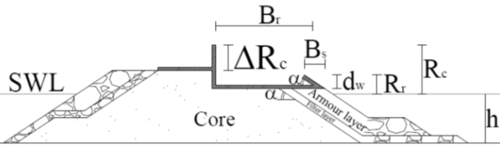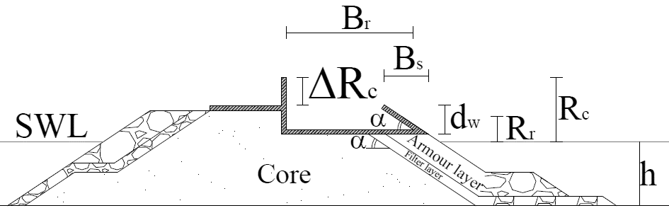
b)
a)
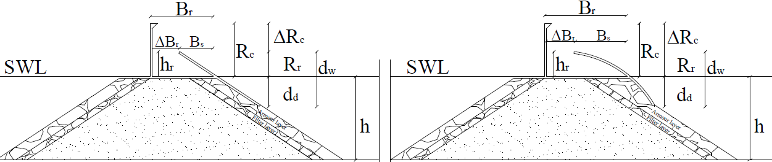
d)
c)

Figure 1. OBREC configurations during the 2012 campaign (a, b) and the 2014 campaign (c, d).

Table 1: Main wave and geometrical characteristics of the laboratory campaigns, at model scale.
 | h [m] | H_{m0} [m] | T_{m-1,0} [s] | R_{c} [m] | R_{r} [m] | B_{r} [m]
2012 | (min–max) | (min–max) | (min–max) | (min–max) | (min–max) | (min–max)
Extreme conditions | 0.30-0.34 | 0.141-0.177 | 1.68-2.26 | 0.20-0.24 | 0.075-0.125 | 0.415-0.488
Extreme conditions with  nose | 0.34 | 0.145-0.161 | 1.66-2.28 | 0.20 | 0.035-0.085 | 0.415-0.488
Production conditions | 0.27 | 0.037-0.138 | 1.05-2.14 | 0.27 | 0.105-0.155 | 0.415-0.488
2014
Small structure | 0.27-0.35 | 0.02-0.12 | 0.76-2.2 | 0.147-0.227 | 0.045-0.129 | 0.219-0.460
Large structure | 0.27-0.35 | 0.05-0.13 | 0.76-2.2 | 0.147-0.227 | 0.045-0.129 | 0.219-0.460
Extra-Large structure | 0.27-0.35 | 0.05-0.118 | 0.76-2.2 | 0.147-0.227 | 0.045-0.129 | 0.219-0.460

Measurements
The sensors along the wave flume and across the structure were used to obtain:
- the wave reflection from the structure;
- the pressures acting on the OBREC cross section; and
- both the average overtopping discharges at the front reservoir q_{reservoir} and inshore the crown wall q_{rear}.
The water overtopping the reservoir was controlled by depth gauges, which activated the pumps to allow the water discharging from the reservoir above a fixed threshold water level. The wave volumes overtopping the crown wall were collected into a box inshore the structure, where a similar control of the water discharge was performed by means of depth gauges. In both cases, the values of q_{reservoir} and q_{rear} were reconstructed by the combination of the signals acquired from the depth gauges and the pumps.
The wave reflection coefficient K_{r} was derived from 4 wave gauges positioned in front of the structure, according to Klopman and Van der Meer (1999) recommendations.
In the 2012 campaign, 3 and 6 pressures transducers were installed in the d_{w,low} and the d_{w,high} configurations respectively; 5 transducers were placed across the reservoir outside bottom, to evaluate the uplift pressure and 17 on the upper/lower crown wall.
In the 2014 campaign, a total of 14 pressure transducers were used to estimate the pressures/forces induced by the waves on the structure. Specifically, 5 pressure transducers were located along the sloping plate, 2 across the reservoir outside bottom, 5 on the lower/upper crown wall and 1 on the parapet.

Main experimental results from both the laboratory campaigns
The OBREC is characterized by similar or reduced values of K_{r} with respect to traditional rubble mound breakwaters. The inclusion of the submerged part of the sloping plate in the 2014 design improves the overtopping rates, while increasing K_{r}. This latter aspect can be also justified by the absence of the berm, according to the results obtained by Zanuttigh et al. (2009).
The q_{reservoir} can be roughly approximated by the formula for dikes by EurOtop (2016), with a friction reduction factor γ_{f} = 0.7.
The selection of the best profile of the sloping plate should be further investigated to balance the energy production and the safety level of structure, e.g. reducing the q_{rear}.
To ensure similar safety level of traditional breakwaters, the OBREC has to be provided with a parapet capable to reduce the average rear overtopping discharge q_{rear} up to the 80% with respect to the original cross section without parapet.
Based on these experimental results the OBREC device led to the integration of a new functionality into an existing or new breakwater, without compromising its primary function of harbor defense.

NUMERICAL MODELLING
The IH-2VOF code, a 2DV RANS-VOF code developed by the University of Cantabria (Losada et al. 2008), was used to model the OBREC device. The numerical modelling focused on the 2012 campaign reproducing both configurations, e.g. d_{w,low} and d_{w,high} (see Fig. 2a). The d_{w,high} was also examined without the berm (see Fig. 2b), similarly to the 2014 campaign. All the geometries were tested under ordinary and extreme wave conditions.

Numerical model set up and tests
In the numerical model, some changes to the original OBREC cross section were needed to assure model stability and correct representation of the physical processes:
- to allow the emptying of the reservoir, a pipe was introduced between the reservoir and the area landward the structure, while in the physical model the overtopping discharge was pumped–out;
- to avoid numerical instabilities, the space between the plate and the reservoir was filled-in and the thickness of the upright section was increased.
The representation of the OBREC porous layers implied the definition of several parameters, which characterize the permeable layers, such as the porosity n, the linear friction coefficient α, the non-linear friction coefficient β, the added mass coefficient c_{A} and the nominal diameter D_{n50}. The sensitivity to the change of these parameters, which were set from the literature (Van Gent 1995, Lynett 2000, Hsu 2002), is shown for q_{reservoir} in the following Section.
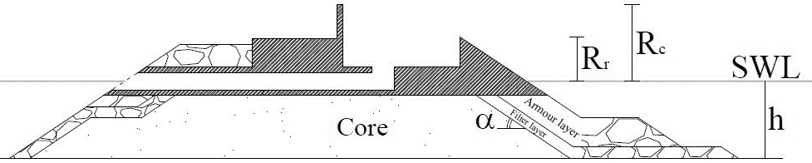
a)
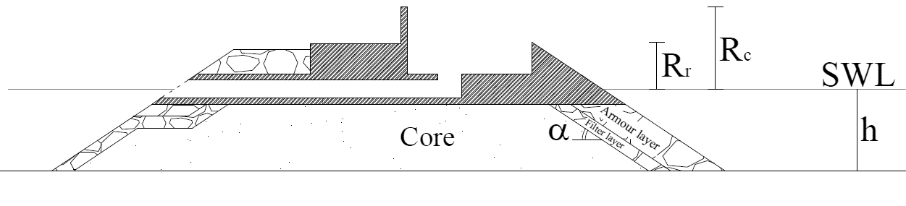
b)

Figure 2. Schematization of the OBREC in the numerical model: a) with berm, and b) without berm.

The tested wave conditions are reported in Table 2, together with the freeboard crest of the sloping plate R_{c}. The numerical wave series were implemented by defining the wave height H_{m0}, the peak period T_{p}, the dispersion factor related to the JONSWAP spectrum γ, the water depth at generation h, the duration of the simulation t and the frequency f. The tests included at least 500 waves, which were found sufficient to perform statistical wave overtopping analysis (Romano et al. 2014). The tests 1.4.1 and 1.5.1 represent the extreme conditions, while the other tests correspond to the ordinary conditions to assess the structural and the hydraulic performance, respectively.

Table 2. Characteristics of the tested wave conditions e relative freeboard crest R_{c}.
Test | H_{m0} [m] | T_{m-1.0} [s] | h [m] | R_{c} [m]
1.4.1 | 0.188 | 1.811 | 0.34 | 0.035
1.5 1 | 0.193 | 2.23 | 0.34 | 0.085
2.1.4 | 0.069 | 1.529 | 0.27 | 0.105
2.1.5 | 0.069 | 1.327 | 0.27 | 0.105
2.1.6 | 0.064 | 1.092 | 0.27 | 0.105
4.1.5 | 0.068 | 1.327 | 0.27 | 0.155
4.1.10 | 0.132 | 2.090 | 0.27 | 0.155
4.1.11 | 0.132 | 1.796 | 0.27 | 0.155
4.1.12 | 0.132 | 1.554 | 0.27 | 0.155

As for the laboratory campaigns, several wave gauges are installed inside the numerical flume to evaluate K_{r}, q_{reservoir} and the pressures acting on the OBREC device.
The wave reflection coefficient K_{r} is derived from the 4 wave gauges located in front of the structure.
The value of q_{reservoir} is computed thanks to a gauge placed on top of the sloping plate (see Fig. 3b), by integrating (along the vertical) cell by cell the horizontal velocity component multiplied by the cell height.
The numerical pressure transducers are placed along the structure in the same position as in the laboratory (Fig. 3). However, in the numerical model, the pressure transducers 13, 12, 11 and 10 (Fig. 3) can be used to evaluate both the uplift and the downward pressures.

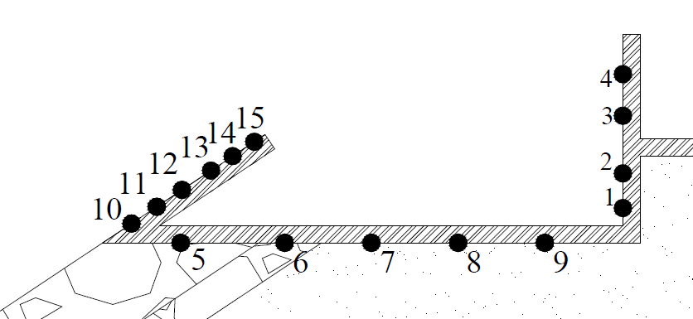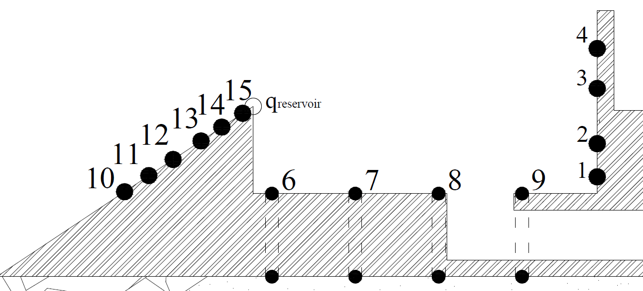
b)
a)

Figure 3. Water gauges across the structure: a) laboratory model, b) numerical model. The two cross sections have the same scale highlighting the necessary modifications to the numerical scheme.

Wave reflection
The results of the wave reflection analysis are reported in Table 3, where the laboratory and the numerical results are compared with the theoretical predictions by Zanuttigh and Van der Meer (2008):

(1)

Equation (1) can be applied to straight slope data in design conditions, e.g. R_{c}/H_{m0} ≥ 0.5, H_{m0}/D_{n50} ≥ 1.0, s₀ ≥ 0.01, under perpendicular wave attack. Equation (1) can be also applied to the structures with berm provided that the slope included in the calculation of the Irribarren and Battjes parameter is the average slope α_{incl} in the run-up/run-down area, e.g. ± 1.5 H_{m0} with respect to the still water level. The slope α_{incl} is here calculated based on the update approach proposed by EurOtop (2016):

(2)

where in this case ${\text{h}}_{\text{sub}}\text{=}\text{min}\left(\text{1.5}{\text{∙H}}_{\text{m0,t}}\text{;} \text{h}\right)\text{,} {\text{h}}_{\text{em}}\text{=} \text{min(1.5}{\text{∙H}}_{\text{m0,t}}\text{;}{\text{ R}}_{\text{c}}\text{)}$, B is the horizontal extension of the berm and h_{b} its submergence with respect to the still water level. The berm falls below the run-down for the tests characterized by the smallest H_{m0}, e.g. 2.1.4, 2.1.5 2.1.6 and 4.1.5 (in Table 2), and therefore the average slope α_{incl} is indeed the slope of the sloping plate α_{off}. The Irribarren and Battjes surf similarity parameter ξ₀ is computed as:

(3)
The values of the coefficients a and b were set equal to 0.12 and 0.87, e.g. rubble mound breakwaters. The prediction formula overestimates the values of K_{r} for the tests where the structure is schematised as a straight slope breakwater, e.g. the first 4 in Table 3, while it tends to slightly underestimate those ones affected by the effectiveness of the berm, e.g. the last 3 tests in Table 3.
The numerical model systematically overestimates the experimental results and the deviation is on average the 35%. This result can be partially justified by the increased length of the sloping plate in the numerical model, with respect to the experiments. It can also be partially explained by the need to optimize the model calibration for both q_{reservoir} and K_{r}.
The absence of the berm produces an increase of K_{r} of the 26% on average, as it could have been expected based on the results by Zanuttigh et al. (2009). This previous numerical work showed that the structures with a submerged berm were characterized by a lower K_{r} than the corresponding straight slopes. A toe protection is therefore recommended especially if the OBREC is installed in a breakwater without berm.

Table 3. Laboratory and predicted K_{r} vs. numerical model results, for the configurations with and without berm. Results for all the ordinary tests in Table 1.
 | 2.1.4 | 2.1.5 | 2.1.6 | 4.1.5b | 4.1.10b | 4.1.11b | 4.1.12b
Laboratory | 0.24 | 0.21 | 0.18 | 0.23 | 0.43 | 0.36 | 0.27
Zanuttigh et al. | 0.45 | 0.40 | 0.35 | 0.40 | 0.34 | 0.30 | 0.27
Mod. With berm | 0.45 | 0.40 | 0.31 | 0.39 | 0.58 | 0.52 | 0.46
Mod. Without berm | / | / | / | 0.53 | 0.69 | 0.63 | 0.58

Wave overtopping discharge
The model calibration was carried-out to optimize the representation of both K_{r} and q_{reservoir}. Table 4 reports, for a specific test, the numerical results q_{reservoir,n} obtained by changing the porosity values (Palma et al. 2016), and keeping constant the other material parameters (α = 1000, β = 1.1, 1.0 and 0.8 for the armour layer, the filter layer and the core, respectively).
Figure 4 shows the values of q_{reservoir,n} compared with the corresponding experimental ones q_{reservoir,e} and the design formulae related to sloping structures (q_{reservoir,p}), developed by Van der Meer and Bruce (2013) and adopted by the EurOtop (2016), e.g. eq. 1 and 2:

(4)

with the maximum:

(5)

In the equations above, α_{off} represents the offshore slope angle, γ_{b} is the berm influence factor, γ_{f} is the roughness influence factor, γ_{b} the oblique wave attack influence factor, γ_{ν} is the influence factor for a vertical wall and ξ_{m-1,0} is the breaker parameter and R_{r} is the front wall freeboard crest.
The lower the values of q_{reservoir}, the better the agreement among experiments, numerical and theoretical predictions (eq. (2) and (3)). With increasing q_{reservoir}, the numerical results are closer to the experiments than the predictions, as it was expected considering that the formulae are essentially based on traditional structures and the calibration of γ_{f} is questionable (Vicinanza et al. 2014). The values of q_{reservoir} increases for the OBREC layout compared to a traditional breakwater with similar overall dimensions, since the offshore rock slope is partially replaced by a concrete sloping plate (Vicinanza et al. 2014).
Table 5 reports the comparison of q_{reservoir} between the configurations with and without berm. The OBREC performance remains constant, at least for the tests characterized by the greater discharge rates. In presence of the berm the dissipation by breaking is higher, but the values of K_{r} are lower than without the berm, leading to similar q_{reservoir}.

Table 4. Laboratory vs. model overtopping discharges obtained by varying the porosities assigned to the layers (Test 2.1.5).
Configuration | Armour | Filter | Core | q_{reservoir},_{e} [l/s/m] | q_{reservoir,n} [l/s/m]
1 | 0.8 | 0.7 | 0.6 | 0.046 | 0.073
2 | 0.7 | 0.6 | 0.05 | 0.046 | 0.056
3 | 0.6 | 0.05 | 0.04 | 0.046 | 0.006
4 | 0.7 | 0.05 | 0.04 | 0.046 | 0.004

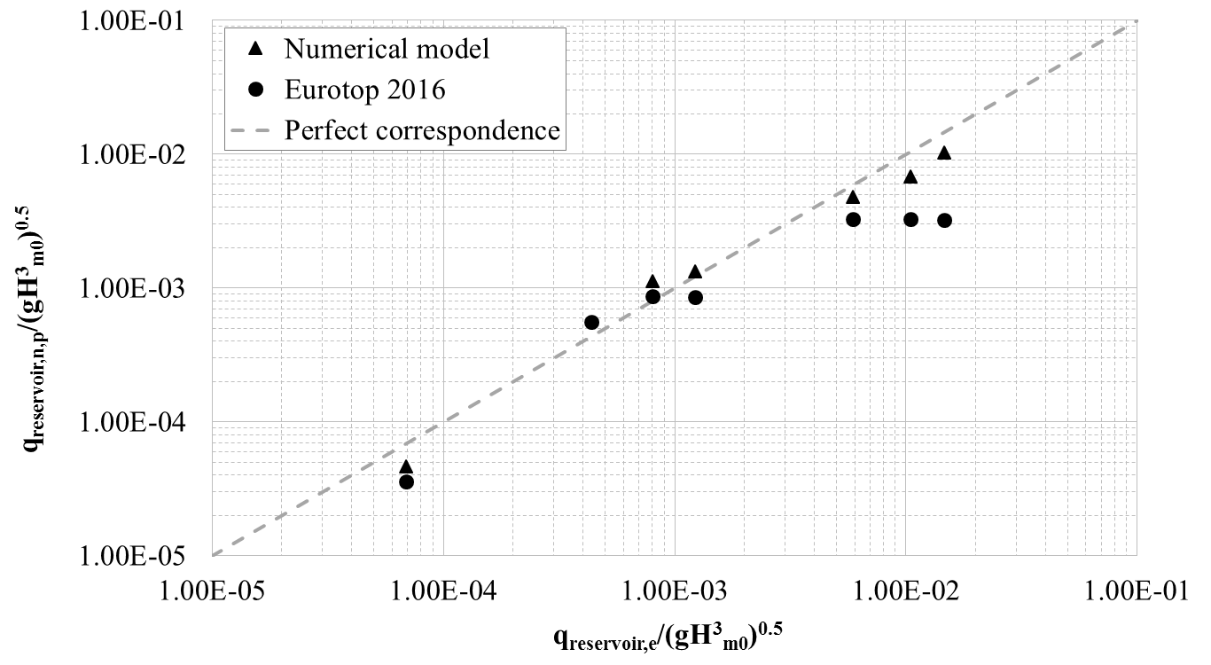
Figure 4. Computed (numerical and predicted by formulae) non-dimensionalised values of q_{reservoir,n/p} vs. laboratory non-dimensionalised values of q_{reservoir,e}, for the ordinary wave conditions in Table 2.

Table 5. Comparison of the q_{reservoir} values [l/s/m] between the configurations with and without berm.
Test | With berm | Without berm
4.1.5b | 0.0038 | 0.0020
4.1.10b | 0.96 | 0.89
4.1.11b | 0.62 | 0.59
4.1.12b | 0.41 | 0.40

Pressures across the structure
The pressure analysis is focused on the OBREC performance in extreme conditions (Tests 1.4.1, e.g. d_{w,low} configuration and 1.5.1 in Table 2, e.g. d_{w,high} configuration). The experimental and numerical pressures are reported in terms of p₂₅₀, which corresponds to the non-exceedance level of about 99.7%.
During the extreme tests, the lab equipment was insufficient to pump-out the water from the reservoir. Therefore, in the numerical modelling, two schematizations have been proposed to analyse the loads acting on the plate and across the reservoir for d_{w,low} configuration (Tables 6 and 7):
- the same cross section modelled during the calibration (Model 1 in Tables 6 and 7). This scheme is closer to the real prototype configuration, which was tested in more recent experiments (Contestabile et al. 2016).);
- the structure with a closed reservoir as in the laboratory experiments (Model 1 in Tables 6 and 7). The two Models 1 and 2 were considered to schematise the best and the worst case respectively, e.g. the full or partial incapacity of the reservoir to let the water flowing out.
Table 6 reports the pressures acting on the sloping plate and the uplift ones related to the reservoir. Model 2 gives a better estimation of the experiments than Model 1, both for the plate and the reservoir. In case of the uplift pressures, Model 1 overestimates the statistical values due to the presence of the pipe that decreases the porous part of the structure. Inside the reservoir, Model 2 gives higher statistical values of the downward pressures than Model 1, as it is expected since the overtopping waves cannot be partially discharged through the pipe. As aforementioned, no direct comparison of numerical versus experimental data inside the reservoir is possible, however the dynamics reproduced by Model 2, e.g. the overtopping waves hitting the full reservoir, should be more similar to the prototype operating in extreme conditions and therefore represents cautious conditions.
According to the results for d_{w,low} configuration, Model 2 was selected to test also the case of d_{w,high}, with and without a berm. Tables 8 reports the experimental and numerical pressures acting along the sloping plate, on the reservoir (e.g. uplift pressures) and at the crown wall. Model 1 gives a good estimation of the experimental values, mainly in the lower part of the plate. The absence of the berm does not change the general trend, leading to slightly higher statistical values, as for the downward pressures inside the reservoir (Table 9). In both Models, the uplift p₂₅₀ are well estimated. The discrepancy among the numerical and experimental pressure at the crown wall increases from the bottom to the top.
As already discussed in Contestabile et al. (2016), the modelling of complex structures, such as the OBREC device, is not always sufficient to obtain the complete and accurate description of its structural response. In this study, the dynamics related to violent wave impacts with very short duration may be strongly affected by the compressibility of the air pocket. The air entrainment process was not examined in details in the lab and is not reproduced by this version of the IH-2VOF. Therefore, the actual values of the pressures at prototype conditions may substantially differ from the measurements and from the computations. The dynamics inside the reservoir and on the wall will be further investigated thanks to the monitoring of the pilot installed in 2016 in the port of Naples.

Table 6. Laboratory (Lab) vs. numerical p250, values in kPa. The numbers correspond to the gauges in Figure 3. Results for Test 1.4.1.
With berm 2012 | 10 | 11 | 12 | 6 | 7 | 8 | 9
Lab | 1.12 | 1.54 | 1.40 | 1.86 | 1.47 | 1.33 | 1.13
Model 1 | 1.43 | 1.20 | 0.82 | 2.32 | 2.23 | 2.13 | 2.02
Model 2 | 1.54 | 1.32 | 1.00 | 2.24 | 2.08 | 1.91 | 1.72

Table 7. Numerical downward p250, values in kPa. The numbers correspond to the gauges in Figure 3. Results for Test 1.5.1.
With berm 2012 | 6 | 7 | 8 | 9
Model 1 | 1.23 | 1.22 | 1.17 | 1.86
Model 2 | 1.36 | 1.46 | 1.60 | 1.92

Table 8. Laboratory (Lab) vs. numerical uplift pressures p₂₅₀, values in kPa. The numbers correspond to the gauges in Figure 3. Results for Test 1.5.1.
Model 2 | 10 | 11 | 12 | 13 | 14 | 15 | 6 | 7 | 8 | 9 | 1 | 2 | 3 | 4
Lab | 1.66 | 1.54 | 1.44 | 1.45 | 1.82 | 1.96 | 2.09 | 1.89 | 1.84 | 1.52 | 2.75 | 2.67 | 2.70 | 1.67
With berm | 1.68 | 1.50 | 1.30 | 1.09 | 1.01 | 0.58 | 2.30 | 2.13 | 1.95 | 1.75 | 2.18 | 1.77 | 1.52 | 0.97
Without berm | 1.69 | 1.53 | 1.35 | 1.12 | 1.07 | 0.62 | 2.28 | 2.11 | 1.94 | 1.74 | 2.11 | 1.72 | 1.32 | 0.91

Table 9 Numerical downward p250, values in kPa. The numbers correspond to the gauges in Figure 3. Results for Test 1.5.1.
Model 2 | 6 | 7 | 8 | 9
With berm | 1.71 | 1.60 | 1.80 | 2.06
Without berm | 1.73 | 1.60 | 1.83 | 2.07

Comparison with other numerical approaches
The laboratory and model values of q_{reservoir} and K_{r} are here compared with the results obtained with the Artificial Neural Network (ANN) adopted by EurOtop (2016) and developed by Zanuttigh et al. (2016) and Formentin et al. (2017). This tool is able to deal with a variety of wave attacks and complicated structure geometries through the use of 15 physical parameters describing the structure cross-sections and the hydraulic conditions. Figure 5a reports the general schematization of the structures - that was partially derived from the CLASH project (Van der Meer et al., 2009) - and the main parameters adopted by the ANN tool. The full list of the 15 parameters of the ANN is given in both the above-mentioned works of the authors. The ANN is here used to derive K_{r} and q_{reservoir}.
The OBREC structural features have been schematized according to the parameters of Fig. 5a, resulting in the final layout shown in Figure 5b. By comparing Fig. 5b with the original configurations of the lab and the model cross-sections (Fig. 1a-b and 2a-b, respectively), it can be observed that the scheme provided to the ANN (Fig. 5b) includes some simplifications of the shape of the sloping plate and of the reservoir. These elements are indeed too peculiar to be represented by means of the 15 parameters of the ANN tool. Moreover, in order to be consistent with the lab measure of q_{reservoir}, the presence of the crown wall and of the reservoir have been neglected, leading to the following adaptations:
- the maximum structure emergence comprehensive of the crown wall (R_{c}) results equal to the value of the crest emergence (A_{c}), see Fig. 5a;
- the crest width G_{c} is set equal to 0;
- the values of roughness factor (γ_{fd}) and the mean size of the structure elements (D_{d}) in the run-down area (i.e. within +1.5H_{m0,t} below the still water level) are respectively set to 0.4 and 0.05 m to represent the two layers of rocks;
- the values of roughness factor (γ_{fu}) and the mean size of the structure elements (D_{u}) in the run-up/down area have been computed on the basis of a weighted average of the γ_{f} and D values characterizing rock slope (γ_{f} = 0.4 and D = 0.05 m) and the impermeable sloping plate (γ_{f} = 1 and D = 0 m), similarly to the approach for αincl in eq. 1. The resulting values of the γ_{f} and D for the 7 tests are resumed in Table 10. Note that for the tests 4.1.10b, 4.1.11b and 4.1.12b, that are characterized by a higher sloping plate (see Fig. 1b) involving the whole run-up area, the average γ_{f,u} and D are respectively equal to 1 and 0.
The other structural elements such as the foreshore, the toe and the berm are included in the general schematization shown in Figure 5a.

Table 10. Values of roughness factors (γ_{f}) and of the mean sizes of the structure elements (D) characterizing the OBREC slope in the run-up (subscripts ‘u’) and run-down (subscripts ‘d’) area.
Test | γ_{f,d} [-] | γ_{f,u} [-] | D_{d} [m] | D_{u} [m]
2.1.4 | 0.40 | 0.63 | 0.05 | 0.03
2.1.5 | 0.40 | 0.63 | 0.05 | 0.03
2.1.6 | 0.40 | 0.63 | 0.05 | 0.03
4.1.5b | 0.40 | 0.63 | 0.05 | 0.03
4.1.10b | 0.40 | 1 | 0.05 | 0
4.1.11b | 0.40 | 1 | 0.05 | 0
4.1.12b | 0.40 | 1 | 0.05 | 0

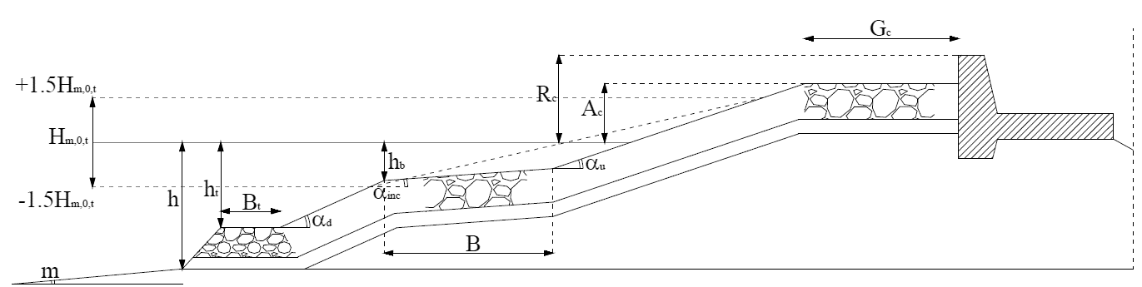
a)
b)
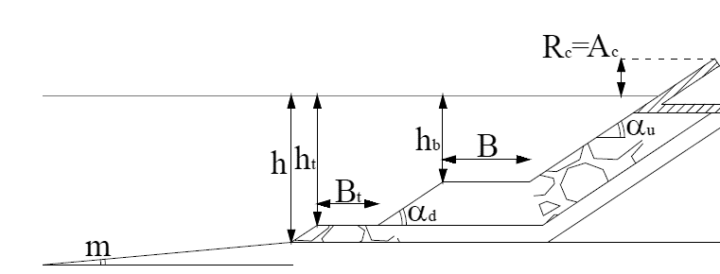
Figure 5. a) General schematisation of the structure based on CLASH. b) OBREC schematisation to evaluate q_{reservoir}.

The results of the application of the ANN tool to the OBREC device are numerically reported in Table 11 in terms of q_{reservoir}, and graphically shown in Figures 4 and 6, in terms of q_{reservoir} and K_{r}, respectively.
For each test, Table 11 compares the lab values of q_{reservoir} with the corresponding predictions obtained with the ANN, the numerical model and the EurOtop (2016) formulae. In order to ease the quantitative analysis of the performance of the three methods, the Table includes, for each method, the average values of the standard deviation σ and of the coefficient of determination R² computed between measurements and predictions. The numerical values of both the error indices reveal that the ANN predictions are accurate and on average the most precise with respect to the other methods.
As for K_{r}, Figure 6 indicates that the ANN tool gives a general overestimation of a factor 2 of the experimental values when K_{r,e} < 0.3, while it provides accurate predictions for the larger K_{r,e} (tests 4.1.10b, 4.1.11b). The ANN tends therefore to overestimate K_{r} for the configurations with the submerged berm as well as the numerical model, see Tab. 10.

Table 11. Experimental (Lab), numerical (IH-2VOF) and predicted (EurOtop) values of q_{reservoir} vs. ANN results. The values are in [m³/s/m].
Test | Lab | ANN | IH-2VOF | EurOtop (2016)
2.1.4 | 1.22E-03 | 8.98E-04 | 1.34E-03 | 4.82E-03
2.1.5 | 8.02E-04 | 5.54E-04 | 1.12E-03 | 4.85E-03
2.1.6 | 4.36E-04 | 2.26E-04 | 0.00E+00 | 3.68E-03
4.1.5b | 6.90E-05 | 1.04E-04 | 4.64E-05 | 6.51E-04
4.1.10b | 1.47E-02 | 1.05E-02 | 1.03E-02 | 1.11E-02
4.1.11b | 1.05E-02 | 7.34E-03 | 6.78E-03 | 1.12E-02
4.1.12b | 5.90E-03 | 4.91E-03 | 4.81E-03 | 1.12E-02
R² |  | 0.86 | 0.83 | -
σ |  | 0.0020 | 0.0022 | 0.0052

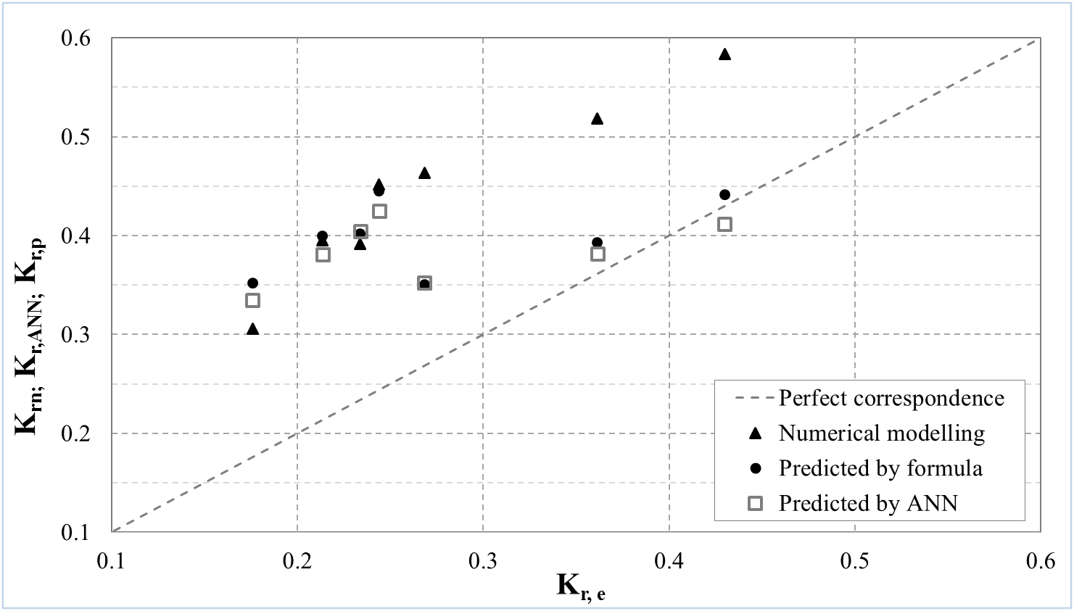

Figure 6. Computed values of K_{r} (numerical, predicted formulae and by the ANN, respectively K_{r},_{n}, K_{r,ANN} and K_{r,p}) vs. laboratory values of K_{r} (K_{r,e}) for the ordinary wave conditions in Table 2.

CONCLUSIONS
This paper presents an overview of the two laboratory campaigns, carried-out at Aalborg University, and a numerical analysis, performed with the 2DV RANS-VOF code IH-2VOF, of the multifunctional harbour structure OBREC. The hydraulic and the structural performance of the OBREC with respect to a traditional rubble mound breakwater is evaluated by means of ordinary and extreme tests.
The IH-2VOF model can be used to extend the experimental database and to provide indications for design optimization. Particular attention should be paid to the representation of the flow motion through thin adjacent permeable and impermeable layers.
The model is calibrated to represent two OBREC configurations with berm, which differ only for the height of the sloping plate (d_{w,low} and d_{w,high}). The calibration (Palma et al. 2016) is carried-out by comparing the laboratory and the numerical values of the average wave overtopping discharge inside the reservoir (q_{reservoir}) and of the wave reflection coefficients (K_{r}), under ordinary wave conditions. The d_{w,high} configuration is then tested without the berm to analyse the change of the OBREC performance.
The numerical values of q_{reservoir} are compared with the EurOtop (2016) formulae and a new artificial neural network (ANN) recently developed by Zanuttigh et al. (2016). The numerical model and the ANN give a better estimation of the experimental results, especially for the greater discharges, than the theoretical formulae developed for traditional breakwaters. The ANN tool provides good results even if the schematisation of the peculiar OBREC cross section, according to the reference CLASH structure, needed some adaptations.
The laboratory values of K_{r} are compared with the numerical results, the predictions of the ANN and the theoretical results derived from the formula by Zanuttigh and Van der Meer (2008). The numerical model systematically overestimates the experiments of the 35% on average. Both the formula and the ANN predictions overestimate the values of K_{r} when the berm falls below the run-down area.
The OBREC structural performance is evaluated in extreme conditions, by comparing the numerical and the experimental results in terms of statistical values of pressures, e.g. p₂₅₀. Numerical simulations provide information on loads acting on different part of the structure also where no experimental data are available (a.o. downward pressures in the reservoir). The uplift values of p₂₅₀ in the reservoir and in the lower part of the sloping plate are well represented, if the structure is modified by closing the reservoir to reproduce the full-section operating condition of the reservoir during extremes. The laboratory pressures at the crown wall are underestimated and the discrepancy increases from the wall bottom to the top, may be due to violent wave impacts with very short duration, which may be strongly affected by the compressibility of the air pocket. The air-entrainment phenomenon is not reproduced by this version of the IH-2VOF and will be further investigated thanks to the monitoring of the pilot installed in 2016 in the port of Naples.
The performance of the d_{w,high} configuration without berm is compared the corresponding case with the berm, leading to similar results with the exception of the wave reflection coefficients. The absence of the berm causes an increase of K_{r} of the 26% on average. This result is coherent with the study performed by Zanuttigh et al. (2009), in which the structures with a submerged berm were characterized by a lower K_{r} than the corresponding straight slopes. A toe protection is therefore recommended especially if the OBREC is installed in breakwaters without berm.

ACKNOWLEDGMENTS
The support RITMARE flagship project (www.ritmare.it) is gratefully acknowledged. Laboratory investigations were part of the National Operational Programme for "Research and Competitiveness" 2007-2013 (NOP for R&C) founded project PON04a3_00303 titled “DIMEMO-DIga Marittima per l’Energia del Moto Ondoso” (Maritime Breakwater for Wave Energy Conversion), Project PON04a3_00303 (www.dimemo.eu). Authors gratefully acknowledge the Italian Ministry of Education, University and Research (MIUR) for supporting this innovative research.

REFERENCES
Azzellino, A., D. Conley, D. Vicinanza, and J. Kofoed. 2013. Marine Renewable Energies: Perspectives and Implications for Marine Ecosystems, Scientific World Journal, vol. 2013, 547–563.
Buccino, M., D. Stagonas, and D. Vicinanza. 2015b. Development of a composite sea wall wave energy converter system, Renewable Energy, 81, 509–522.
Buccino, M., D. Vicinanza, D. Salerno, D. Banfi, and M. Calabrese. 2015a. Nature and magnitude of wave loadings at Seawave Slot-cone Generators, Ocean Engineering, 95, 34–58.
Cappietti L. and P.L. Aminti. 2012. Laboratory investigation on the effectiveness of an overspill basin in reducing wave overtopping on marina breakwaters. Proceedings of International Conference on Coastal Engineering, 1(33).
Contestabile P., Ferrante V., Di Lauro E. and D. Vicinanza. 2016a. Full-scale prototype of an overtopping breakwater for energy conversion, Proceedings of International Conference on Coastal Engineering.
Contestabile, P., C. Iuppa, E. Di Lauro, L. Cavallaro, T. Lykke Andersen, and D. Vicinanza, 2017a. Wave loadings acting on innovative rubble mound breakwater for overtopping wave energy conversion, Coastal Engineering, 122, 60–74.
Contestabile, P., E. Di Lauro, M. Buccino, and D. Vicinanza. 2017b. Economic assessment of Overtopping BReakwater for Energy Conversion (OBREC): a case study in Western Australia, Sustainability, 9(1), 51.
Contestabile, P., Ferrante, V., Di Lauro, E., and D. Vicinanza. 2016b. Prototype Overtopping Breakwater for Wave Energy Conversion at Port of Naples. Proceedings of 26th International Conference on ISOPE, Rhodes, Greece, pp. 616–621.
Contestabile, P., V. Ferrante, and D. Vicinanza. 2015. Wave Energy Resource along the Coast of Santa Catarina (Brazil), Energies 8(12), 14219–14243.
Eurotop. 2016. In: Pullen, T., Allsop, N.W.H., Bruce, T., Kortenhaus, A., Schüttrumpf, H., van der Meer, J.W. (Eds.), Wave Overtopping of Sea Defences and Related Structures – Assessment Manual. www.overtopping-manual.com.
Formentin S.M., Zanuttigh B. and J.W. van der Meer. 2017. A neural network for predicting wave reflection, overtopping and transmission, Coastal Engineering Journal, 59, No. 2, 1750006, 31 pp.
Goda, Y. 1973b. A new method of wave pressure calculation for the design of composite breakwater. Rept. Port and Harbour Res. Inst., Vol. 12, No. 3, pp. 31-70, (in Japanese) or Proceedings of 14th International Conference on Coastal Engineering, ASCE, Copenhagen, pp. 1702-1720.
Hsu, Tian-Jian, Tsutomu Sakakiyama, and Philip L-F. Liu. 2002. A numerical model for wave motions and turbulence flows in front of a composite breakwater, Coastal Engineering, 25-50.
Iuppa, C., Contestabile P., Cavallaro L., Foti E. and D. Vicinanza. 2016. Hydraulic Performance of an Innovative Breakwater for Overtopping Wave Energy Conversion. Sustainability, 8.12, 1226.
Jacobsson, Staffan, and Johnson A. 2000. The diffusion of renewable energy technology: an analytical framework and key issues for research. Energy policy, 28.9, 625-640.
Klopman, G., J.W. van der Meer. 1999. Random wave measurements in front of reflective structures. Journal Waterw. Port Coastal Ocean Engineering, 125 (1), 39–45.
Kofoed, J. P. 2002. Wave Overtopping of Marine Structures – Utilization of Wave Energy. Ph. D. Thesis, Hydraulics & Coastal Engineering Laboratory, Department of Civil Engineering, Aalborg University, December.
Kofoed, J.P., Frigaard, P., Friis-Madsen, E., and H.C. Sørensen. 2006. Prototype testing of the wave energy converter Wave Dragon. Renewable Energy, 31, 181–189.
Losada, I.J., Lara J.L, Guanche R., J.M. and Gonzales-Ordina. 2008. Numerical analysis of wave overtopping of rubble mound breakwaters. Coastal Engineering, 55.1, 47-62.
Lynett, P. J., Liu, P. L.-F., Losada, I. J. and C. Vidal. 2000. Solitary Wave Interaction with Porous Breakwater. Waterway, Port, Coastal and Ocean Engineering, 314-322.
M. R. A. Van Gent. 1995. Porous flow through rubble-mound material. Journal of waterway, port, coastal, and ocean engineering, 176-181.
Nam, B. W., Shin, S. H., Hong, K. Y., and S. W. Hong. 2008. Numerical simulation of wave flow over the Spiral-Reef overtopping device. The 8th ISOPE Pacific/Asia Offshore Mechanics Symposium. International Society of Offshore and Polar Engineers.
Nørgaard, J.H., Andersen, T.L., and H.F. Burcharth. 2013. Wave loads on rubble mound breakwater
Palma G., Contestabile, P., Formentin, S.M., Zanuttigh B. and D. Vicinanza. 2016. Design optimization of a multifunctional wave energy device. Proceedings of the 2nd International Conference on Renewable Energies Offshore, Lisbon, Portugal.
Romano A., Bellotti G., Briganti R., and L. Franco. 2014. Uncertainties in the physical modelling of the wave overtopping over a rubble mound breakwater: the role of the seeding number and of the test duration. Coastal Engineering, 103, 15–21.
Van der Meer, J.W. and T. Bruce. 2013. New physical insights and design formulas on wave overtopping at sloping and vertical structures. Journal of Waterway, Port, Coastal, and Ocean Engineering.
Van Doorslaer, K. and J. De Rouck. 2010. Reduction on Wave Overtopping on a Smooth Dike by Means of a Parapet. Proceedings of the 32nd International Conference on Coastal Engineering, Shanghai, China.
Van Doorslaer, K., De Rouck, J., Audenaert, S. and V. Duquet. 2015. Crest modifications to reduce wave overtopping of non-breaking waves over a smooth dike slope. Coastal Engineering, 101, 69–88.
Vicinanza, D., and P. Frigaard. 2008. Wave pressure acting on a seawave slot-cone generator. Coastal Engineering, 55 (6), 553–568.
Vicinanza, D., Contestabile, P. and V. Ferrante, 2013b. Wave energy potential in the north-west of Sardinia (Italy). Renewable Energy, 50(0): 506-521.
Vicinanza, D., Contestabile, P., Harck Nørgaard, J., T. Lykke Andersen. 2014. Innovative rubble mound breakwaters for overtopping wave energy conversion. Coastal Engineering, 88, 154–170.
Vicinanza, D., J.H. Nørgaard, P. Contestabile, and T. Lykke-Andersen. 2013a. Wave loadings acting on overtopping breakwater for energy conversion, Journal of Coastal Research, Special Issue 65, 1669–1674.
Zanuttigh B., Angelelli E., Kortenhaus A., Koca K., Krontira Y., and P. Koundouri. 2016a. Methodology for multi-criteria design of multi-use offshore platforms for marine renewable energy harvesting, Renewable Energy, 85, 1271-1289.
Zanuttigh B., Formentin S.M., and J.W. van der Meer. 2016b. Prediction of extreme and tolerable wave overtopping discharges through an advanced neural network, Ocean Engineering, 127, 7-22.
Zanuttigh, B., and Jentsje W. van der Meer. 2008. Wave reflection from coastal structures in design conditions. Coastal Engineering, 55.10, 771-779.
Zanuttigh, B., Van der Meer, J. W., Lykke Andersen, T., Lara J. L. and Inigo J. Losada. 2009. Analysis of wave reflection from structures with berms through an extensive database and 2DV numerical modelling, Proceedings of International Conference on Coastal Engineering, 4, 3285-3297.

DICAM, University of Bologna, V.le Risorgimento 2, Bologna, BO, 40136, Italy
Department of Civil Engineering, Design, Building, and Environment, University of Campania “Luigi Vanvitelli”, Caserta 81100, Italy
CONISMA - National Inter-University Consortium of Marine Sciences, Piazzale Flaminio 9, Roma, Italy

