Vaquero Country: Tracing the Latin Origins of the American Cowboy
David Cota
The image of the “cowboy” has long been perpetuated as that of a white American man. This stereotype has been reinforced for decades through Western films and television shows, featuring actors such as John Wayne and Clint Eastwood—icons who have come to represent Western culture. However, the first cowboys in America were not white men. Many of them were vaqueros—a Spanish term meaning “cowboy”—who were of mixed heritage or descended from Native American, Spanish, or African ancestry. As historian Lakshmi Gandhi notes, “Vaqueros were trained by the Spaniards on land known as Mexico.” The origins of vaqueros date back to the colonial era, when they became skilled horsemen who managed cattle on vast ranches in the American Southwest during the 1800s. Known for their exceptional horsemanship, roping techniques, and cattle-handling abilities, vaqueros were the true pioneers of cowboy culture. Yet, American history has largely failed to recognize their contributions, leaving overdue credit owed to the Mesoamerican vaqueros of the nineteenth century.
Although there are few official records of individual vaqueros during the 1800s, several notable figures embody their spirit and legacy. One such figure is Bass Reeves, one of the first Black deputy U.S. Marshals and a former enslaved man. Born in Crawford County in 1838, Reeves escaped to Indian Territory during the Civil War and gained his freedom in 1863. He later settled in Arkansas as a farmer before being appointed as a deputy U.S. Marshal in 1889, taking an oath to “faithfully execute lawful orders” (Reeves, 1889). Reeves dedicated the remainder of his life to law enforcement and died in 1910. Figures like Bass Reeves played a vital role in shaping Western culture, though they were rarely acknowledged as equals due to their race. Despite his accomplishments, Reeves—like many vaqueros of African, Native, or mixed descent—was denied social equality. Vaqueros were often viewed as laborers rather than landowners and were positioned at the bottom of colonial and frontier hierarchies. Many were mestizos (of Native American and Spanish ancestry), criollos (Spaniards born in the Americas), or of African descent.
There is no denying that vaqueros have been underrepresented in popular culture. Their influence on the American cowboy is undeniable—from cattle herding and roping to the very style of cowboy clothing. The cowboy hat, boots, and the ever-present horse—now quintessential symbols of the American West—were all integral parts of vaquero tradition.
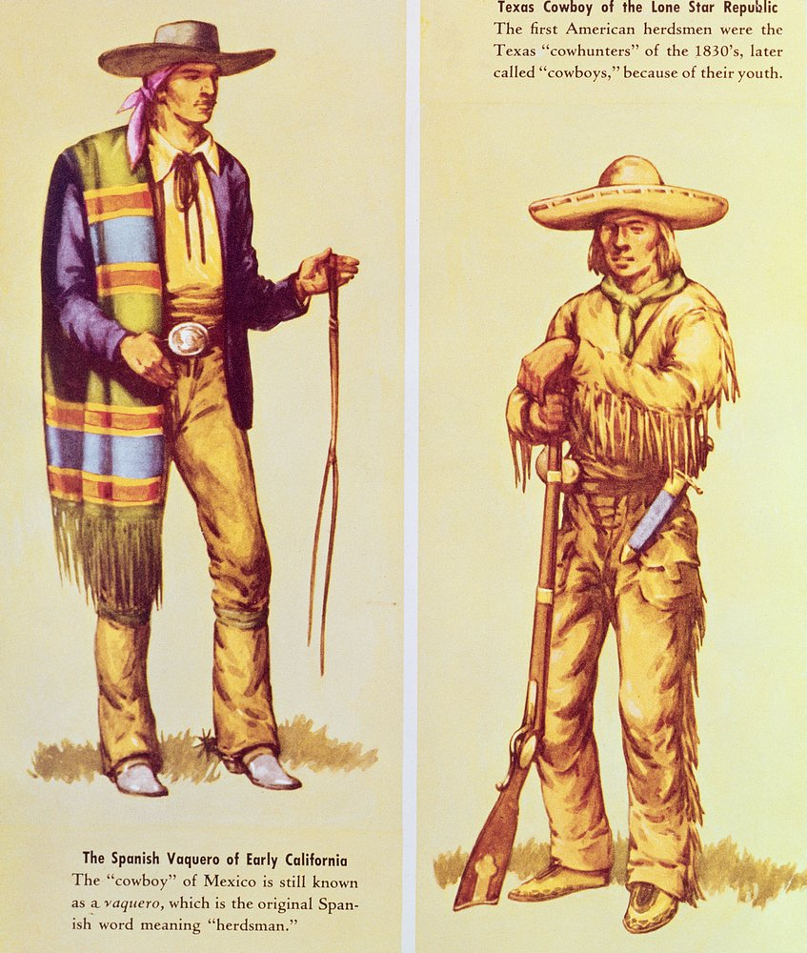
A historical photograph of a vaquero in the Southwest, for instance, reveals familiar imagery: a man on horseback, wearing a wide-brimmed hat, and holding a lasso—all elements that have become synonymous with Western culture for centuries.
To understand why the image of the vaquero faded, we must look to history. In “Vaqueros: All-American Cowboys,” historian Melanie Cole explains that the Hispanic influence on cowboy culture dates back to the 1500s. Across Spanish colonies in the Americas, various regional terms were used to describe cowboys: huasos in Chile, gauchos in Argentina, llaneros in Venezuela, and vaqueros in Mexico. Cole notes that “the middle and upper classes, haciendas, and ranchos perpetuated the elite social status and power of the landholders.” In contrast, vaqueros represented the working class—often mestizos who were excluded from the social elite. Their labor sustained the ranching economy, but their contributions were marginalized. Cole further emphasizes that the U.S. model of ranching was derived from Mexican practices. Yet, vaqueros faced racial discrimination and class prejudice, often being stereotyped as “lazy or untrustworthy.” In reality, vaqueros were anything but lazy—they were skilled laborers whose hard work formed the foundation of the cowboy tradition. Their erasure from mainstream narratives reflects a broader pattern of minimizing the labor and influence of nonwhite communities in American history.
J. Frank Dobie’s 1931 article The Mexican Vaquero of the Texas Border illustrates this bias. Dobie recounts meeting a vaquero named Genardo Bosques, who helped him recover a lost horse by identifying hoofprints. Although Dobie admired Bosques’s skill, he described him as “indifferent to any kind of suffering,” implying a lack of humanity. This portrayal reflects how American writers often misinterpret the stoicism of vaqueros, who had endured generations of hardship and labor. Far from indifferent, vaqueros had simply been conditioned by systemic oppression to persevere in silence.
Vaquero culture was not limited to Texas or New Mexico—it also thrived in California. Idwal Jones’s article, “Bow-Legged Pioneers,” recounts the experiences of vaqueros who migrated from Sonora and Jalisco to California. He highlights Jo Mora, a vaquero who, along with the Californios, became one of the first to practice “cow punching”—a technique dating back to the sixteenth century in which cattle were prodded with poles to move them into chutes during drives. However, the decline of the Mission system, which had provided labor for Indigenous workers, contributed to the waning presence of Californian vaqueros. In “California’s Last Vaquero,” author Gerald Haslam profiles Arnold Rojas, a vaquero who preserved California’s ranching traditions. Rojas was renowned for “herding cattle, doctoring horses on the ranges of the Kern County Land Company, and riding for J.J. Lopez on Rancho Tejon.” His life exemplified the resilience and continuity of vaquero culture despite its gradual erasure. While the number of vaqueros declined, their traditions endured—though often through cultural appropriation. Practices such as rodeos, horse wrangling, cattle herding, and lassoing all originated from vaquero customs. Haslam notes that while Hollywood produced countless Western films celebrating fictional cowboys, the real vaqueros continued their labor largely unseen. Their stories survived mainly through secondhand accounts, further contributing to their marginalization in public memory.
One enduring example of vaquero tradition is the rodeo. First held in 1925, the La Fiesta de los Vaqueros had, by the early 1930s, become an annual cultural institution, featuring competitions such as steer wrestling, calf roping, and saddle bronc riding—all rooted in vaquero heritage. Without the vaqueros, there would be no cowboys. Every custom, skill, and symbol of the cowboy can be traced back to these early Mesoamerican horsemen. The vaquero was more than a laborer; he was a craftsman, a herdsman, and a cultural bridge between Mexico and the United States. His legacy endures in the fabric of Western culture, even if his name has been forgotten. To fully understand the history of the American cowboy, we must also recognize the foundational influence of the vaquero—because without vaqueros, there is no cowboy.
Understanding the true history of the cowboy means recognizing the Black, Indigenous, and Latino figures who shaped this tradition, even when popular culture erased or misrepresented them. From the vaqueros of the Spanish Southwest to Black cowboys like Bass Reeves, these individuals built the skills, culture, and legends that Hollywood would later claim as its own. The persistence of this misrepresentation is still visible today, as seen when Lil Nas X faced pushback for “Old Town Road,” and why Beyoncé’s “Cowboy Carter” resonates so powerfully—reclaiming space for Black voices in a genre historically built on their contributions. This history is not just a story of the past; it is lived and remembered in families and communities. We also see modern Latin artists such as Carin Leon taking on country but infusing it with Latin and soul influences. My uncle, a charro in Pico Rivera, embodies this legacy, showing how vaquero and cowboy traditions continue to thrive, shaping culture, identity, and understanding across generations. Recognizing and honoring these contributions enables us to view the American West—and the cowboy—not as a single, narrow image, but as a rich tapestry of people, skills, and stories that continue to inspire us today.

Lakshmi Gandhi, “How Mexican Vaqueros Inspired the American Cowboy,” (History Channel, 2021).
Melanie Cole, “Vaqueros: All American Cowboys,” Hispanic Vol. 8, No. 1 (1995), pp. 2-3.
J. Frank Dobie, “The Mexican Vaquero of the Texas Border,” The Southwestern Political and Social Science Quarterly, Vol. 8, No. 1 (June, 1927), pp. 15-26.
Idwal Jones, “Bow-Legged Pioneers,” The New York Times, June 26, 1949.
Gerald Haslam, “California’s Last Vaquero,” The Western Literature Association Vol. 21, No. 2, (Summer, 1986), pp. 123-130.

